
JK-SMD0805-100 PPTC DEVICES Edition：A0
Part Number：Q/JKTD-6-100 Page No: 1 OF 3

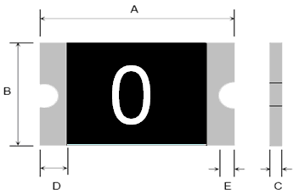

Terminal pad materials :Tin-Plated Nickle-copper

Terminal pad solderability : Meets EIA specification RS 186-9E and ANSI/J-STD-002 Category 3.

Marking : Part identification 0=100
Table1 :DIMENTION(Unit : mm)
Model | Marking | A |  | B |  | C |  | D | E
Model | Marking | Min. | Max. | Min. | Max. | Min. | Max | Min. | Min.
JK-SMD0805-100 | 0 | 2.00 | 2.20 | 1.20 | 1.50 | 0.50 | 1.30 | 0.20 | 0.10

Table2 :PERFORMANCE RATINGS:
Model | Marking | V_{max}  (Vdc) | I_{max}  (A) | I_{hold}  @25℃  (A) | I_{trip}  @25℃  (A) | P_{d}  Typ  (W) | Maximum  Time To Trip |  | Resistance
 |  |  |  |  |  |  | Current  (A) | Time  (Sec) | Ri_{min}  (Ω) | Ri_{typ}  (Ω) | R1_{max}  (Ω)
JK-SMD0805-100 | 0 | 6.0 | 100 | 1.00 | 1.95 | 0.60 | 8.0 | 0.30 | 0.060 | 0.120 | 0.230

Table3:Test Conditons and Standards
Item | Test Conditon | Standard
Initial Resistance | 25℃ | 0.060～0.230Ω
I_{H} | 25℃，1.00A，60min | No Trip
Ttrip  ._{trip} | 25℃，8A，6.0V | ≤0.30s
Trip endurance | 6V，100A，60min | No arcing or burning

Operating Temperature：-40℃ TO 85℃
Packaging：Bulk ,4000pcs per bag

SHENZHEN JINRUI ELECTRONIC MATERIAL CO.,LTD 6 F DISTRICT NO. 3000046 BLDG Hi-Tech SCIENCE & INDUSTRY PARK SHANGKENG COMMUNITY GUANLAN STREET BAOAN SHENZHEN
TEL：0755－26546327 26584158 FAX： 0755－26546562
Web Site：www.jkpptc.com E-mail:customer@jkpptc.com

JK-SMD0805-100 PPTC DEVICES Edition：A0
Part Number：Q/JKTD-6-100 Page No: 2 OF 3
Solder reflow conditions

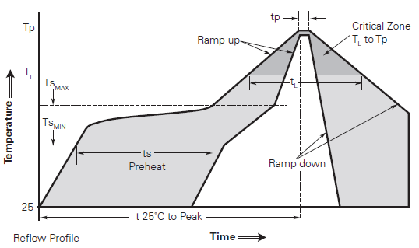
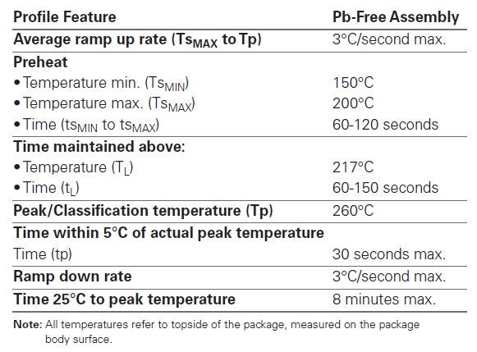
● Recommended reflow methods: IR, vapor phase oven, hot air oven, N2 environment for lead-free.
● Devices are not designed to be wave soldered to the bottom side of the board.
● Recommended maximum paste thickness is 0.25mm (0.010inch).
● Devices can be cleaned using standard industry methods and solvents.
● Soldering temprature profile meets RoHs leadfree process.

Notes: If reflow temperatures exceed the recommended profile, devices may not meet the
performance requirements

SHENZHEN JINRUI ELECTRONIC MATERIAL CO.,LTD 6 F DISTRICT NO. 3000046 BLDG Hi-Tech SCIENCE & INDUSTRY PARK SHANGKENG COMMUNITY GUANLAN STREET BAOAN SHENZHEN
TEL：0755－26546327 26584158 FAX： 0755－26546562
Web Site：www.jkpptc.com E-mail:customer@jkpptc.com

JK-SMD0805-100 PPTC DEVICES Edition：A0
Part Number：Q/JKTD-6-100 Page No: 3 OF 3
Recommended pad layout (mm)
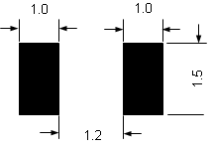
WARNING
· Use PPTC beyond the maximum ratings or improper use may result in device damage and possible electrical arcing and flame.
· PPTC are intended for protection against occasional over current or over temperature fault conditions and should not be used when repeated fault conditions or prolonged trip events are anticipated.
· Device performance can be impacted negatively if devices are handled in a manner inconsistent with recommended electronic, thermal, and mechanical procedures for electronic components.
· Use PPTC with a large inductance in circuit will generate a circuit voltage (L di/dt) above the rated voltage of the PPTC.
· Avoid impact PPTC device its thermal expansion like placed under pressure or installed in limited space.
· Contamination of the PPTC material with certain silicon based oils or some aggressive solvents can adversely impact the performance of the devices.PPTC SMD can be cleaned by standard methods.
· Requests that customers comply with our recommended solder pad layouts and recommended reflow profile. Improper board layouts or reflow profilecould negatively impact solderability performance of our devices.
SHENZHEN JINRUI ELECTRONIC MATERIAL CO.,LTD 6 F DISTRICT NO. 3000046 BLDG Hi-Tech SCIENCE & INDUSTRY PARK SHANGKENG COMMUNITY GUANLAN STREET BAOAN SHENZHEN
TEL：0755－26546327 26584158 FAX： 0755－26546562
Web Site：www.jkpptc.com E-mail:customer@jkpptc.com

