产品规格书
PRODUCT SPECIFICATION

客户名称：
CUSTOMER：

产品名称：
PRODUCT NAME： 贴片保险丝 SMD FUSE

型号规格：
MODEL DETAIL：12H (RoHS Compliant) 250mA-10A 63V抗浪涌型(High Inrush Current Withstand)

料 号：
PART NO.： 12H1500C

供货商： 深圳市良胜电子有限公司
SUPPLIER： SHENZHEN LANSON ELECTRONICS CO., LTD.

地 址： 深圳市宝安区福永富桥第三工业区A18栋
ADDRESS： A18th Bldg, Fuqiao 3rd Industrial Zone, Fuyong Town. Baoan District, Shenzhen.

编 制  PREPARED BY | 审 核  CHECKED BY | 批 准  APPROVED BY |  | 承 认  SIGNATURE | 审 核  CHECKED BY | 批 准  APPROVED BY
供方签章：  SUPPLIER：  日期：  DATE：2019.02.21 |  |  |  | 需方签章：  CUSTOMER：  日期：  DATE：

SHENZHEN LANSON ELECTRONICS CO., LTD. | PRODUCT  SPECIFICATION | EDITION NO. | A/5
SHENZHEN LANSON ELECTRONICS CO., LTD. | PRODUCT  SPECIFICATION | FILE NO. | LS/C-005-34
SHENZHEN LANSON ELECTRONICS CO., LTD. | MODEL: 12H | PAGE | PAGE 1 OF 5

- 适用范围Scope of Application
本产品适用于各种电子电路中起过电流保护作用。
This product is suitable for various kinds of electronic machines to work for over current protection.

2. 相关标准及认证Relevant Standards and Certification
2.1执行标准Standard: UL248-1、UL248-14
2.2认证Certification
认证  Certification | 认证范围  Scope of Certification | 证书编号  Certification No.
UL | 100mA~30A | E221465

3. 结构尺寸及原材料明细Structure Size and Material Detail
3.1 结构尺寸Structure Size (unit: mm)

①
②
③
④
⑤
0.65±0.2
3.2±0.2
1.6±0.2
0.5±0.2

3.2 原材料明细Material Detail
编号 No. | 零件名称Part Name | 材质Material
① | 电极Electrode | 银Silver
② | 涂层Coating | 玻璃浆Glass cover
③ | 端头End Termination | 镀银Silver plated
④ | 熔丝Fuse element | 银Silver
⑤ | 基片Substrate | 陶瓷Ceramic

SHENZHEN LANSON ELECTRONICS CO., LTD. | PRODUCT  SPECIFICATION | EDITION NO. | A/5
SHENZHEN LANSON ELECTRONICS CO., LTD. | PRODUCT  SPECIFICATION | FILE NO. | LS/C-005-34
SHENZHEN LANSON ELECTRONICS CO., LTD. | MODEL: 12H | PAGE | PAGE 2 OF 5

4. 标示Mark
4.1保险丝上需有下列标示:
The fuse shall have the following marking：
额定电流  Ampere Rating | 产品标示  Marking
250mA | .25
375mA | E
500mA | 0.5
750mA | .75
1A | H
1.5A | K
2A | N
2.5A | O
3A | P
3.5A | R
4A | S
4.5A | X
5A | T
6A | F
7A | 7
8A | M
10A | U

SHENZHEN LANSON ELECTRONICS CO., LTD. | PRODUCT  SPECIFICATION | EDITION NO. | A/5
SHENZHEN LANSON ELECTRONICS CO., LTD. | PRODUCT  SPECIFICATION | FILE NO. | LS/C-005-34
SHENZHEN LANSON ELECTRONICS CO., LTD. | MODEL: 12H | PAGE | PAGE 3 OF 5

5. 电气特性Electrical Characteristics
5.1实验条件: 所有测试环境温度为25±5℃。
Test Condition: All electrical characteristics tests are conducted at an ambient temperature of 25±5℃.
5.2时间-电流特性
Time-Current Characteristics
额定电流  Ampere Rating | 额定电流的%  % of Ampere Rating | 熔断时间  Opening Time
0.1A~10A | 100% | 4 hours Min(大于4小时)
0.1A~10A | 250% | 5 S Max(小于5秒)
0.1A~10A | 300% | 0.1 S~3 S
0.1A~10A | 1000% | 0.2 ms~20 ms
5.3额定分断能力：
Interrupting Rating:
50 Amperes at 125V DC (0.1A~5A)
50 Amperes at 63V DC (0.1A~5A)
100 Amperes at 32V DC (6A~10A)
6. 环境特性Environmental Characteristics
6.1使用温度范围Operating Temperature
-40℃~125℃。
6.2保存条件Storage Conditions
相对湿度≤75%，可以存放3年。
Relative humidity≤75%, store 3 years.

7. 可靠性试验Reliability Test
7.1冷热冲击试验Thermal Shock Test
MIL-STD-202G, Method 107G。

SHENZHEN LANSON ELECTRONICS CO., LTD. | PRODUCT  SPECIFICATION | EDITION NO. | A/5
SHENZHEN LANSON ELECTRONICS CO., LTD. | PRODUCT  SPECIFICATION | FILE NO. | LS/C-005-34
SHENZHEN LANSON ELECTRONICS CO., LTD. | MODEL: 12H | PAGE | PAGE 4 OF 5

7.2防潮湿试验Moisture Resistance Test
MIL-STD-202G, Method 106G。
7.3振动试验Vibration Test
MIL-STD-202G, Method 201A。
7.4可焊性试验Solderability Test
MIL-STD-202G, Method 208H, IEC60127-2, IEC60068-2。

8. 时间-电流曲线图Time-Current Curve
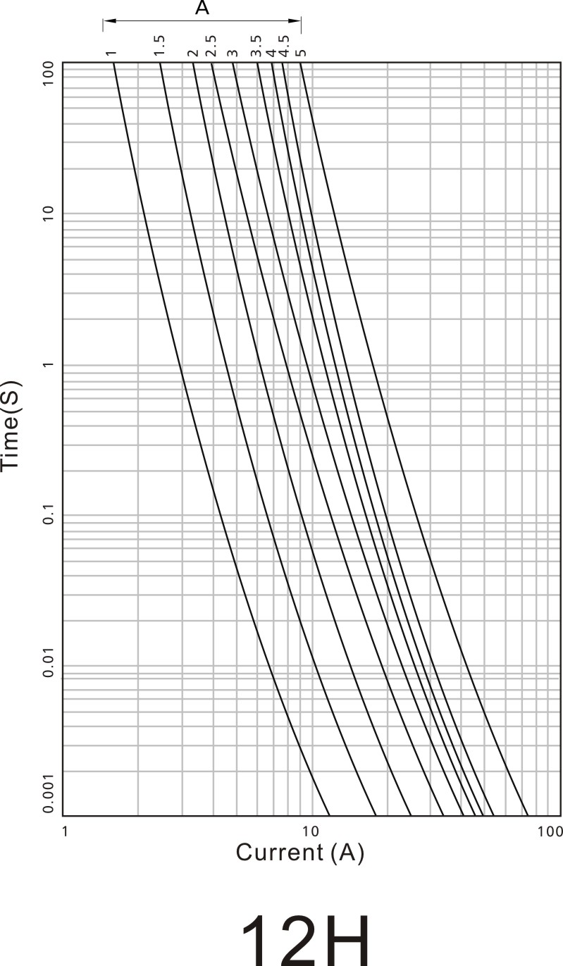

SHENZHEN LANSON ELECTRONICS CO., LTD. | PRODUCT  SPECIFICATION | EDITION NO. | A/5
SHENZHEN LANSON ELECTRONICS CO., LTD. | PRODUCT  SPECIFICATION | FILE NO. | LS/C-005-34
SHENZHEN LANSON ELECTRONICS CO., LTD. | MODEL: 12H | PAGE | PAGE 5 OF 5

9. 焊锡参数Soldering Parameters
9.1 回流焊Reflow Slodering
9.1.1 温度Temperature 260℃
9.1.2 时间Time ≤10 seconds
9.1.3 最大可以承受三次回流焊
Capable for three times reflow
9.2 波峰焊Wave Soldering
9.2.1 温度Temperature 260℃
9.2.2 时间Time ≤10 seconds
9.3 手工焊锡Hand Soldering
9.3.1 温度Temperature 380℃
9.3.2 时间Time ≤3 seconds

10. 包裝Packing
10.1自动机器包装3000PCS/卷。Automaton taped 3000PCS per reel.
10.2包装尺寸Packing Size（unit: mm）

